CT6COPRE REPORT

UP814853

Contents

Design 2

High Concept 2

Virtual Reality Considerations 2

Controls 2

Cockpit 2

Flight mechanics 2

Gameplay Mechanics 2

Standard Game flow 2

Plan 3

Life Cycle 3

Schedule 3

Risks 3

Coding Standards 3

Version Control 3

Testing Plan 3

Reflection 4

The unforeseen issues of virtual reality 4

The flight stick issue 4

The amount I got done 4

# Design

## High Concept

VR Apache Simulator is a fully interactive Apache helicopter simulator. The game will allow the player to fly and operate the apache as the pilot or gunner and gives them a sense of what it would be like to fly the airframe in real life.

## Virtual Reality Considerations

With the whole game being in virtual reality there are an increased consideration opposed to a standard flight simulator game.

The first consideration is the interaction of the cockpit, while a fully interactable cockpit would increase immersion it would also add to the number of objects needing to be collision checked and possibly decrease the performance. Adding to this having such a realistic cockpit would add to the time needed to learn how to fly and would make the game less accessible to a general audience.

The second consideration is the index controllers, with the index controllers you have an increased strain on your wrist because of how you hold the controllers, this makes rotating what you are grabbing increasingly difficult especially if they have forms of RSI. A way to fix this could be to develop the project to use rudders for people who have these issues but that is an expensive fix.

The final consideration is the game performance, virtual reality needs to be a smooth experience especially when flying otherwise users may experience motion sickness when lag spikes occur, the feeling needs to be that they are in a smooth experience that is not jittering around. To do this I will ensure that all scripts are necessary and are not take performance away at all.

## Controls

The grab button on the index controller will be the main interaction for any object that can be picked up and moved around in the cockpit like the Flight Stick and collective. The trigger button will be used for switches or anything else that requires a toggle on/off state, it is also used to fire the weapons. Other buttons include A to switch weapons and B to reset the seated location.

The tracking on the controllers (rotation) will be used to set the joysticks rotation which will set the flight sticks rotation to control the Apache.

## Cockpit

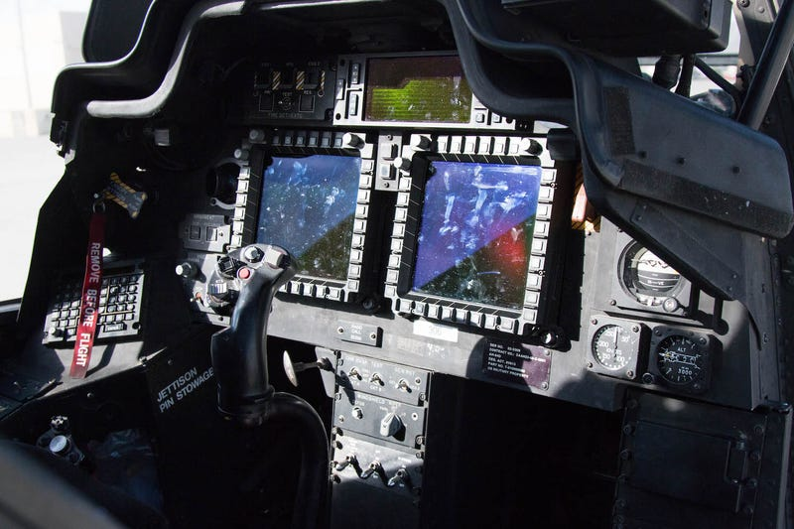

(Brown, 2018)

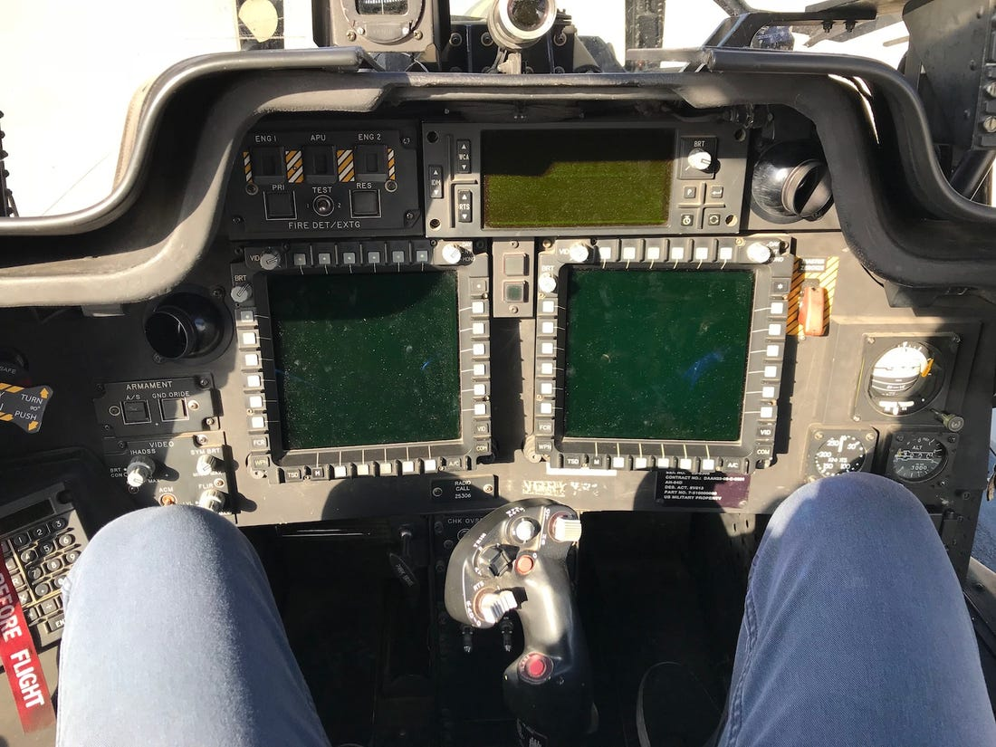

(Brown, 2018)

## Flight mechanics

## Gameplay Mechanics

## Standard Game flow

# Plan

## Life Cycle

## Schedule

## Risks

## Coding Standards

## Version Control

## Testing Plan

# Reflection

## The unforeseen issues of virtual reality

## The flight stick issue